### Automated Network Request Management ServiceNow

**Project Description:**

This project aims to design and implement a streamlined, automated solution for managing network-related service requests within ServiceNow. It enables end users to submit requests for network services through a user-friendly self-service portal.

The system leverages ServiceNow’s workflow engine, catalog items, and approval processes to ensure requests are properly captured, validated, and routed for fulfillment. Upon submission, requests trigger automated notifications, task assignments, and—where applicable—integration with network automation tools or scripts to fulfill standard requests without manual intervention.

**Key Features:**

* Custom service catalog for common network requests
* Dynamic forms to capture relevant request details
* Automated approval workflows based on request type and sensitivity
* Integration with infrastructure management or orchestration tools (optional)
* Real-time status updates and notifications to requesters and technician

**Project Workflow:**

1. **Service catalog creation:**

**Activity 1.1:** Creation of service catalog

**Activity 1.2:** Variables creation

**Activity 1.3:** Variables types

**Activity 1.4:** Variable Set Configuration

**Activity 1.5:** Catalog UI Policy Configuration.

1. **Creation of Table**

**Activity 2.1**: Creation of Table

**Activity 2.2**: Creation of fields

**Activity 2.3**: Creation of field properties.

**Activity 2.3**: Add the field to a form.

1. **Request Approvals Creation(Related list)**

**Activity 3.1**: Creation of Related list

**Activity 3.2**: Adding Related list to table

1. **Creation & Implementation of flows, Actions in flow designer**

**Activity 4.1**: Creation of Flow

**Activity 4.2**: Configuring Trigger

**Activity 4.3**: Configuring actions

**Activity 4.4**: Flow Chart

1. **Final Testing in End User portal & Instance**

**Activity 5.1**: Testing in service portal(End user)

**Activity 5.2**: Testing Emails

**Activity 5.3**: testing with Custom Tables.

# 1: Service catalog creation

# Activity 1.1: Creation of Service catalog

1. Navigate to Application navigator
2. Click on All >> search for Service Catalog
3. Under Service Catalog>> Maintain items
4. Click on New
5. Fill the details >> Name– Network Request
6. Select Catalog>> Service Catalog
7. Select Category>> Network
8. Fill the Short Description as Network request Management
9. 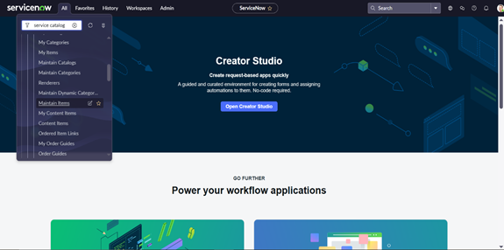Click on Save.

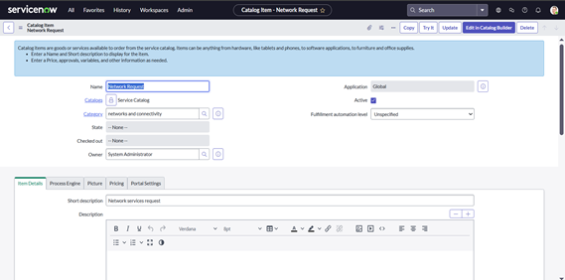

**Activity 1.2: Variables creation:**

1. Select Variables type as Single, Multi line text, reference, choices etc as per requirement
2. Catalog item– Network Request
3. Order–100,200,300,,,,
4. Question– provide the variable label
5. Name–provide the variables name(used for scripting)
6. Tooltip– this will appear when cursor overed on the field.
7. Example text – this will suggest what we need to enter on the field.
8. Mandatory, Read-Only– need to configure on demand
9. Auto populate– need to select dependent variable, apply dot walking to get selected value.
10. Click on Save or Submit.

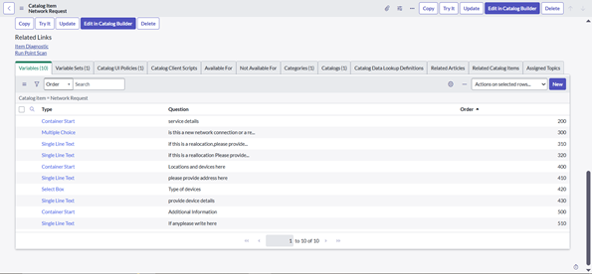

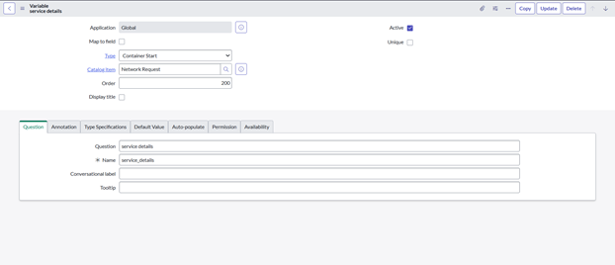

**Activity 1.3: Variable Types**

1. Is this a New connection or Relocation? >> **Choice** >> **New/ Relocation/None**
2. If this is a relocation, Please provide your relocated address here>>**String**
3. Types of devices>> **Choice**>> **Laptop/Mobiles/Others**
4. Please provide address here>>**String**
5. Provide device details here>> **String**
6. If anything else, please specify>> **String**

**Activity 1.4:Variable Set Configuration:**

To enhance form usability:

* Navigate to the **Variable Sets** (optional).
* Follow the same procedure as we used for Variables Creation, for the variable set as well.
* Apply variable sets to the catalog item.

**Variables Types**

1. Opened on behalf of >> Reference>> reference to user table
2. Email Id >> Single line text >> Auto populate by Opened on behalf of variable.
3. User name >>Single line text >> Auto populate by Opened on behalf of variable.
4. Phone Number >>Single line text >> Auto populate by Opened on behalf of variable.
5. Proof of Document >> Attachment

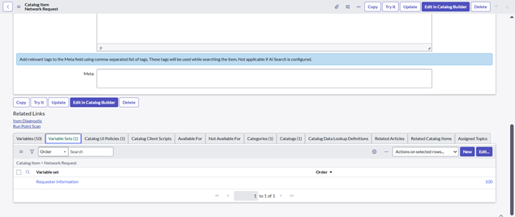

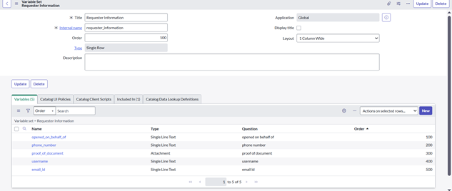

**Activity 1.5:Catalog UI Policy Configuration:**

1. Navigate to catalog items
2. Open Network Request item
3. In related list, we have Catalog UI policy
4. Click on New button to configure New UI policy
5. Select Applies to as Catalog item
6. Select catalog item as Network Request
7. Provide short description, if required
8. Apply condition>> **types of devices** is **others**
9. Clickon save, after saving the form will get UI policy actions in the related list
10. Click on New button to configure new UI Policy action, and Select the variable which we wanto display on condition, make Visible True as per our requirementUpdate the UI Policy and Test the same on Catalog form

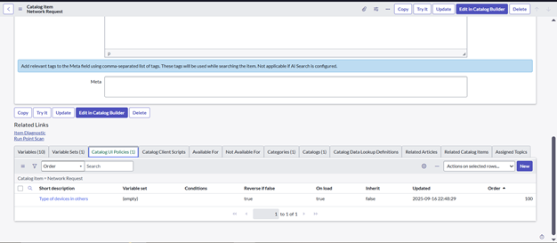

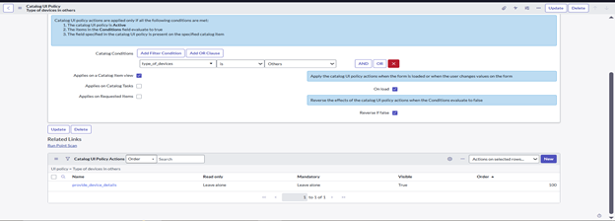

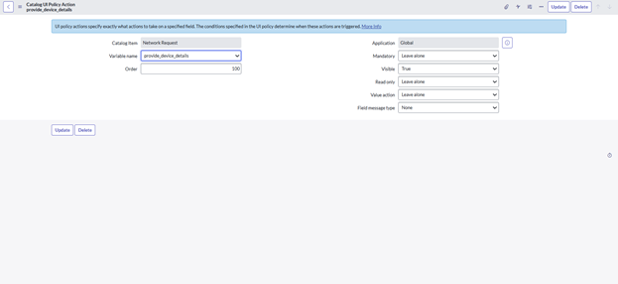

**2: Creation of Table:**

**Activity 2.1: Creation of Table**

**Navigate to**: System Definition > **Tables**.

· Click **New** to create a new table.

· Fill **in Table Information**:

· **Name**: Name of the table ------

· **Label**: Backend name of the table------

· **Auto-generate schema**: Leave it checked.

· Click **Submit** to create the table.

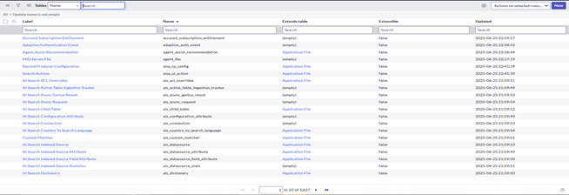

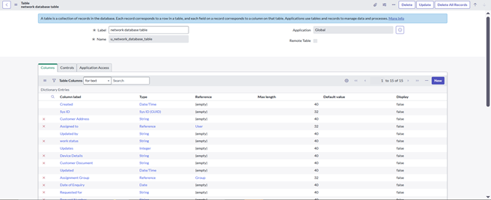

**Activity 2.2: Creation of Fields:**

1. In **Application Navigator**, search **Tables** → click **Tables** under *System Definition*.
2. From the list, find and open the table (e.g., *Network database*).
3. Go to the **Columns tab** to view existing fields.
4. Click **New** (top-right) to add a new field.
5. Fill in the required details for the field (name, type, length, etc.) and save.

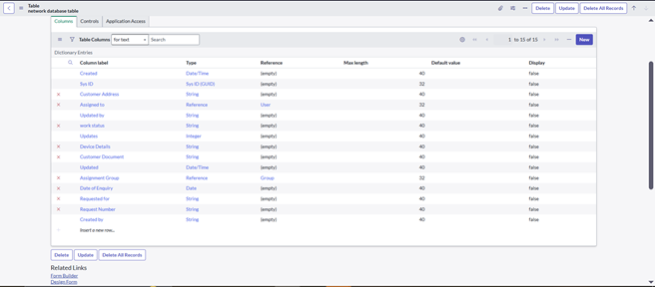

**Activity 2.3: Define Field properties:**

1. Column Label – Display name (e.g., Customer Name).
2. Column Name – Internal name (auto-generated).
3. Type – Data type (String, Integer, Choice, Reference, Boolean, Date).
4. Max Length – Limit for text fields (default 255).
5. Default Value – Pre-filled value for new records.
6. Read-Only – Field cannot be edited.
7. Save – Click Submit to create the field.

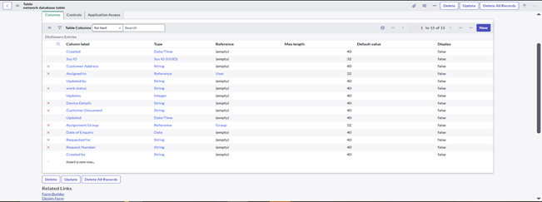

**Activity 2.4:** Add the field to a form.

1.To do this, navigate to **System UI > Forms** in the application navigator.

2. Select the **form** you want to modify (e.g., Incident form).

3. Open the **Form Designer** (click on the "Design" icon).

4. From the **Field Navigator** on the left side, search for the new field you created.

5. Drag the field onto the form layout where you want it to appear.

6. Click **Save** or **Publish** to apply the changes.

**3: Request Approvals Creation(Related list):**

**Activity 3.1: Creation of Related list**

Navigate to **System Definition > Relationships**.

· Click **New** to create a new relationship.

· Fill in the following details:

o **Name**: Approval Request

o **Applies to Table** : Network Database table.

o **Queries from Table** : Sysapprovals table.

o **Active**: Make sure it's set to **True**.

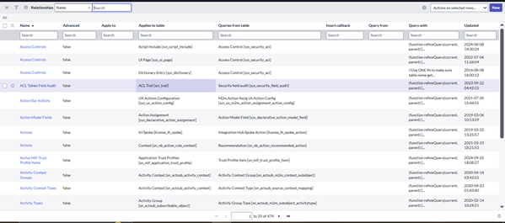

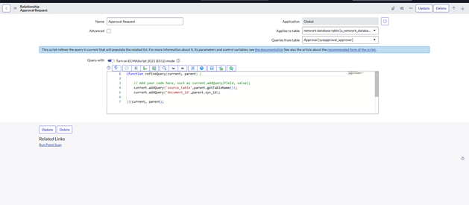

**Activity 3.2**: Adding Related list to table

You can create a **Related List** on a form to display the related records. This helps in easily viewing the relationships between records.

· Navigate to **Form Designer** for the table where you want to show related records.

· Add a **Related List** widget to the form.

· Select the **Related List** you want to show

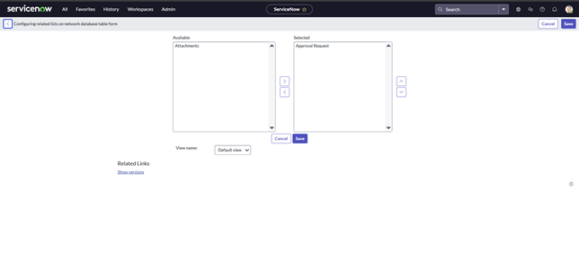

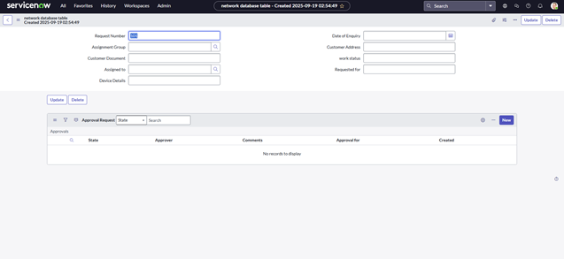

**6.Creation & Implementation of flows, Actions in flow designer**

**Activity 4.1**: Creation of Flow:

1. Navigate to Flow designer home page
2. Click on New to create a new flow
3. Provide flow name as **Network Request**
4. Provide description of flow
5. Click on Build flow.

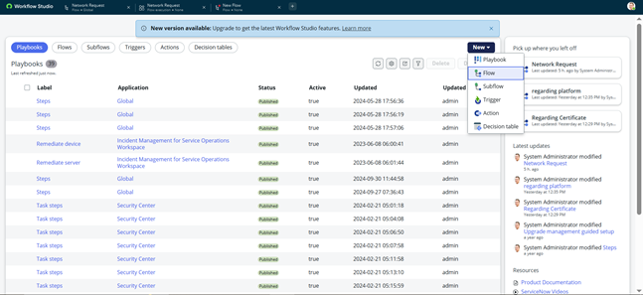

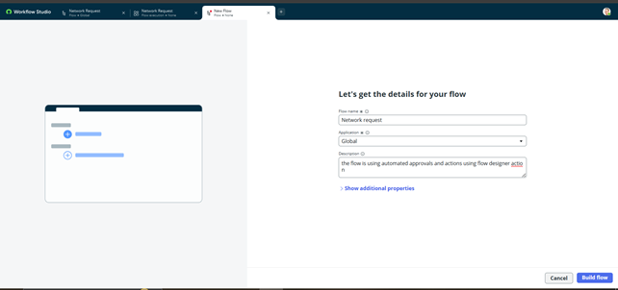

**Activity 4.2**: Configuring Trigger:

1. Click on (+) Icon to Configure the Trigger
2. Select Trigger as Application >> Service catalog
3. Click on **Done.**

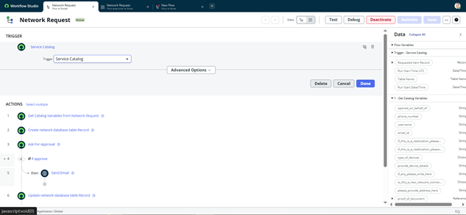

**Activity 4.3**: Configuring actions:

**1.Get Catalog Variables**

* Click on Action, search for Get Catalog Variables
* Select Get Catalog Variables
* Action Inputs>> Trigger>>service catalog>>Requested Item
* Template catalog items >> Select table >> Network Request
* Select the Required Variables and Move to the selected area.

Click on done

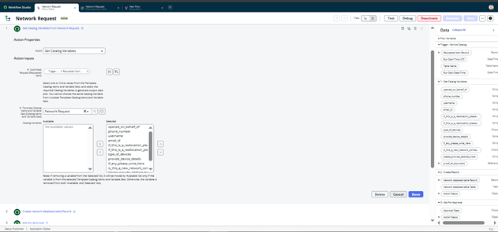

**2.** **Create Record**

* Select action as Create Record
* Select table as Network Database
* Click on Add fields button to configure the fields
* Configure the Required fields as shown in the below picture
* Click on done.

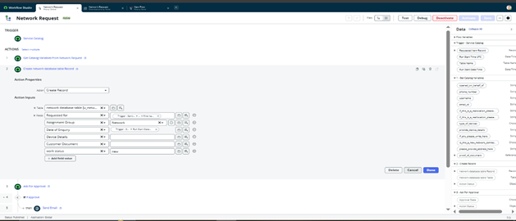

**3.** **Send Email**

* Select action as Send Email
* Select target record >> Create record>> network database table
* Table will be selected automatically
* Cofigure To, CC, BCC as per our requirements(select static/dynamic)
* Provide Subject & Body as shown in the below picture
* Click on done

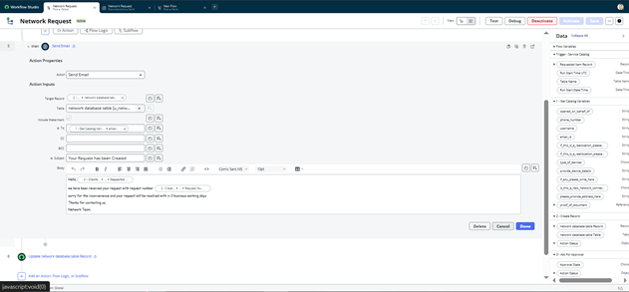

**4.** **Ask for approvals**

* Select action as Ask for Approval
* Select target record >> Create record>> network database table
* Provide Approval Reason>> Waiting for approval
* Configure approval rules>> Approve, reject, approve/reject
* Select approvals as Anyone approves, everyone approves etc.
* We can select approvals like static/dynamic as shown below
* Click on done

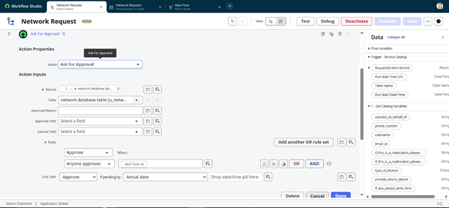

**5.** **Flow Logic**

* Select action as flow logic and Select If condition
* Apply condition >> Ask for approvals state is **Approved/Rejected** as per requirement
* **Click on done**

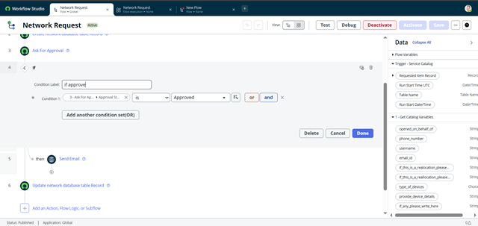

**6 .Update Record**

* Select action as Update Record
* Select record as >> create record>> network database
* Table will be selected automatically
* Configure the fields as per requirement, as shown in below
* Click on done

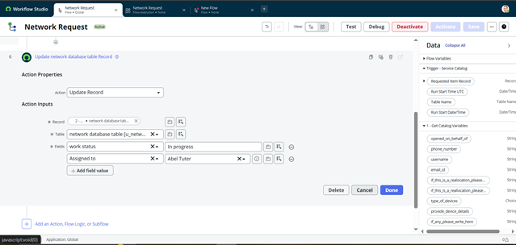

**Activity 4.4**: Flow Chart:

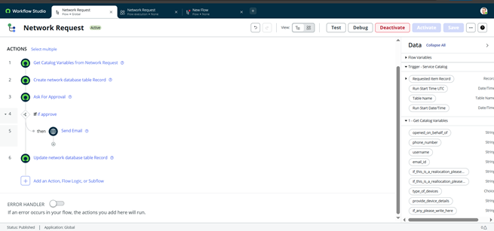

**Final Testing in End User portal & Instance**

**Activity 5.1**: Testing in service portal(End user):

1. Login to ServiceNow PDI
2. Copy the Instance domain ex: [https://dev190678.service-now.com](https://dev190678.service-now.com/).
3. Paste the URL in the Next tab and add Prefix SP to the URL.

ex:<https://dev190678.service-now.com/sp>.

1. Search for **Network Requests**.
2. Fill the required details and click on submit

New Requests will be generated with request numbers and users will get particular emails on the same

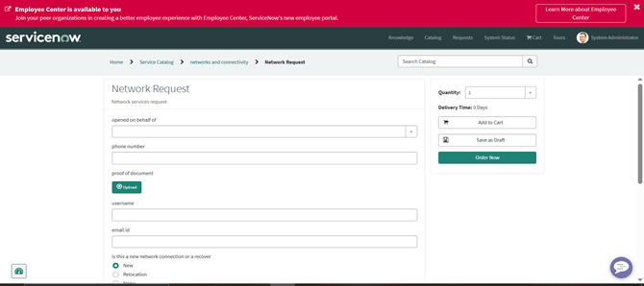

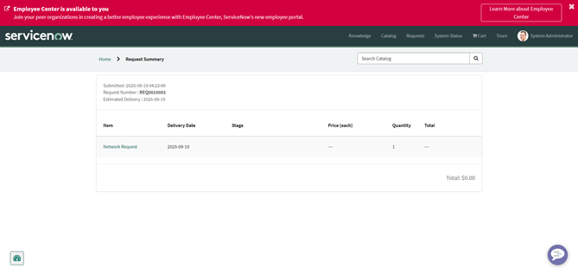

**Activity 5.2**: Testing Emails:

1. Login to ServiceNow PDI
2. System logs>> emails
3. Apply filter>> created on today
4. Search with To, BCC, CC, Subject to get to know what are the emails triggered on the request.

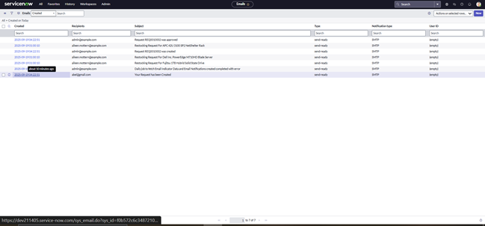

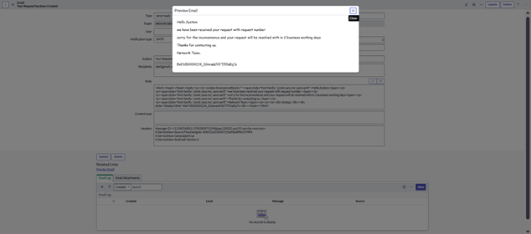

**Activity 5.2**: Testing With Custome tables:

1. Login to ServiceNow PDI
2. System definition >> Tables>> Network database/Network Task
3. After request is generated, Database and task tables fields are automatically filled by the flow

designer configurations

1. Observe the Approvals requests and Changing of States of tables carefully

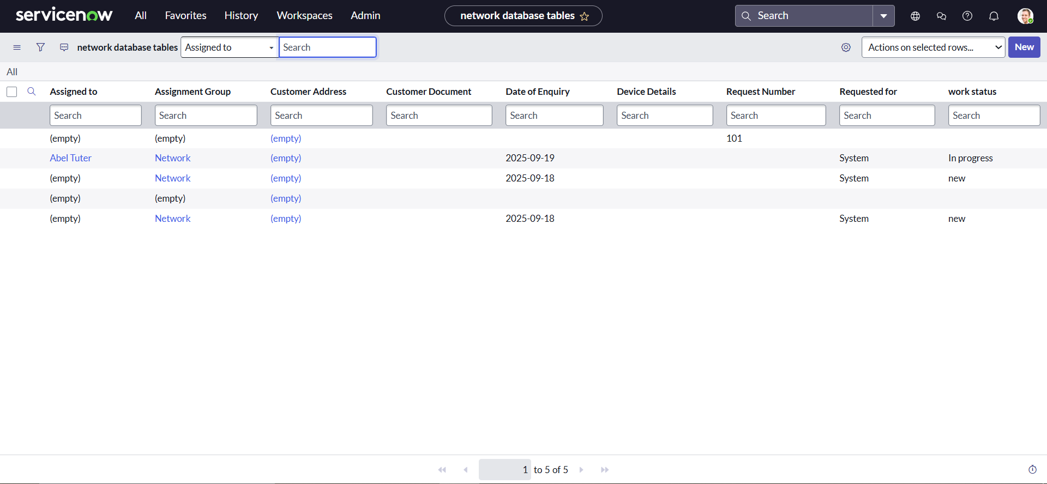

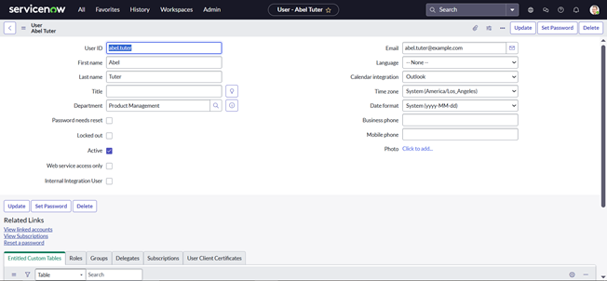

**Conclusion:**

The Automated Network Request Management system in ServiceNow successfully streamlines the end-to-end process of handling network-related service requests. By combining a self-service portal, workflow automation, approvals, and integration with network tools, the solution reduces manual effort, improves accuracy, ensures faster fulfillment, and enhances user experience. This project demonstrates how automation in ServiceNow can bring greater efficiency, transparency, and reliability to IT service delivery.